**#6. Operations with Excel file using Python**

**Roll Number:**

**Date of Submission:**

**Aim:**

To perform following operations on an excel file (“inventory.xlsx”) using Python:

1. List each company with respective product count
2. List products with inventory less than 10
3. List each company with respective total inventory value
4. Write to Spreadsheet: Calculate and write inventory value for each product into spreadsheet

**Tools Required:**

Text editor with Python interpreter.

**Experiment:**

1. ***Code:***

import openpyxl  
  
wb = openpyxl.load_workbook('inventory.xlsx')  
a = {}  
sheet1 = wb["Sheet1"]  
  
totalRows=sheet1.max_row  
supplier = []  
for i in range(2,totalRows+1):  
 supplier.append(sheet1.cell(row=i,column=4).value)  
supplier=[*set(supplier)]  
InventoryValue={}  
productCount={}  
productList=[]  
for supp in supplier:  
 InventoryValue[supp] = 0  
 productCount[supp]=0  
 for i in range(2, totalRows+1):  
 if supp == sheet1.cell(row=i,column=4).value:  
 InventoryValue[supp] = InventoryValue[supp]+sheet1.cell(row=i,column=2).value  
 productCount[supp] = productCount[supp]+1  
 if(sheet1.cell(row=i,column=2).value<10):  
 productList.append(sheet1.cell(row=i,column=1).value)  
  
print("i. List each company with respective product count ")  
print(productCount)  
print("ii. List products with inventory less than 10 ")  
print(productList)  
print("iii. List each company with respective total inventory value ")  
print(InventoryValue)  
sheet2 = wb.create_sheet(index=1,title="sheet2")  
i=0  
j=0  
for supp in supplier:  
 i=i+1  
 cellValue = sheet2.cell(row=i,column=1)  
 cellValue.value = supp  
 cellValue = sheet2.cell(row=i, column=2)  
 cellValue.value = InventoryValue[supp]  
wb.save('inventoryNew.xlsx')

***Result***:  
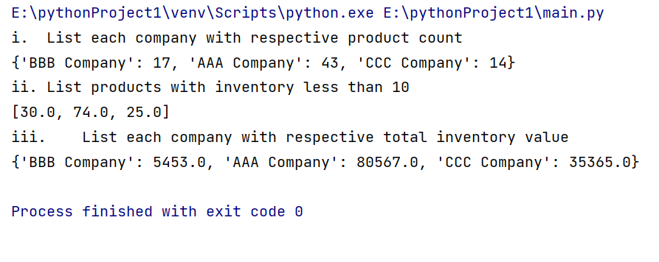

**Inference and Result:**

Thus the following operations on an excel file (“inventory.xlsx”) are performed using Python.